

**DATA ANALYTICS BOOT CAMP**

**By**

**Ishan Mishra Sir**

**Data Analytics Class Notes Report**

**On**

**DATA ANALYSTICS PLAYSTORE - DATA ANALYSIS BOOTCAMP**

Submitted in partial fulfillment of the requirements for the Boot camp Certification

**Bachelor of Technology**

**In**

**Computer Science and Engineering – Data Science**

**Of**

**Garden City University**

By

Gangothri Devi M

**Under the guidance of Ishan Mishra Sir (Bootcamp mentor).**

**DEV TOWN PROJECT:**

**DATA ANALYSIS OF PLAYSTORE NOTES :**

## DAY 1: Decode the Data – Foundations of Data Analytics

### Overview

* Kickoff session introducing DevTown and the bootcamp structure.
* Importance of data analytics in decision-making across industries.
* Roadmap for the 3-day journey: Decode → Visualize → Dominate.

### Key Concepts

* **Data Analytics Definition:** The process of examining datasets to draw conclusions.
* **Types of Analytics:**
  + Descriptive: What happened?
  + Diagnostic: Why did it happen?
  + Predictive: What will happen?
  + Prescriptive: What should be done?

### Tools Introduced

* Python basics
* Jupyter Notebook
* Pandas and NumPy for data manipulation

### Hands-on Task

* Importing PlayStore dataset
* Cleaning nulls, duplicates
* Basic EDA: app categories, installs, ratings

## DAY 2: Visualize the Data – Turning Numbers into Narratives

### Overview

* Recap of Day 1
* Importance of visual storytelling
* How visualizations influence business decisions

### Key Concepts

* Chart types: Bar, Line, Pie, Histogram, Heatmap
* Choosing the right chart for the right data
* Dashboard design principles

### Tools Introduced

* Power BI basics
* Python visualization: Matplotlib, Seaborn

### Hands-on Task

* Creating Power BI dashboard for PlayStore data
* Visualizing installs vs ratings
* Filtering by category and content rating

## DAY 3: Dominate with Data – From Analysis to Action

### Overview

* Recap of Day 2
* Transitioning from insights to impact
* Career guidance and portfolio building

### Key Concepts

* Feature engineering: creating new variables
* Correlation analysis: identifying relationships
* Predictive modeling basics: Linear Regression, Decision Trees

### Tools Introduced

* Scikit-learn for modeling
* Power BI advanced features (DAX)
* GitHub and LinkedIn for showcasing projects

### Hands-on Task

* Building a simple regression model to predict installs
* Exporting dashboard and sharing on LinkedIn
* Resume tips for data analyst roles

**NOTE:**

I sincerely thank you, Ishan Mishra sir, for your inspiring guidance and clear explanations throughout the bootcamp. Your dedication to teaching and patience in resolving every doubt made learning truly enjoyable. Each session was a step forward in my data science journey, and I’m grateful for the knowledge shared. Looking forward to applying these insights and making you proud with my future work.

**REFERENCE SCREENSHOTS:**

**DAY 1 SCREENSHOTS:**

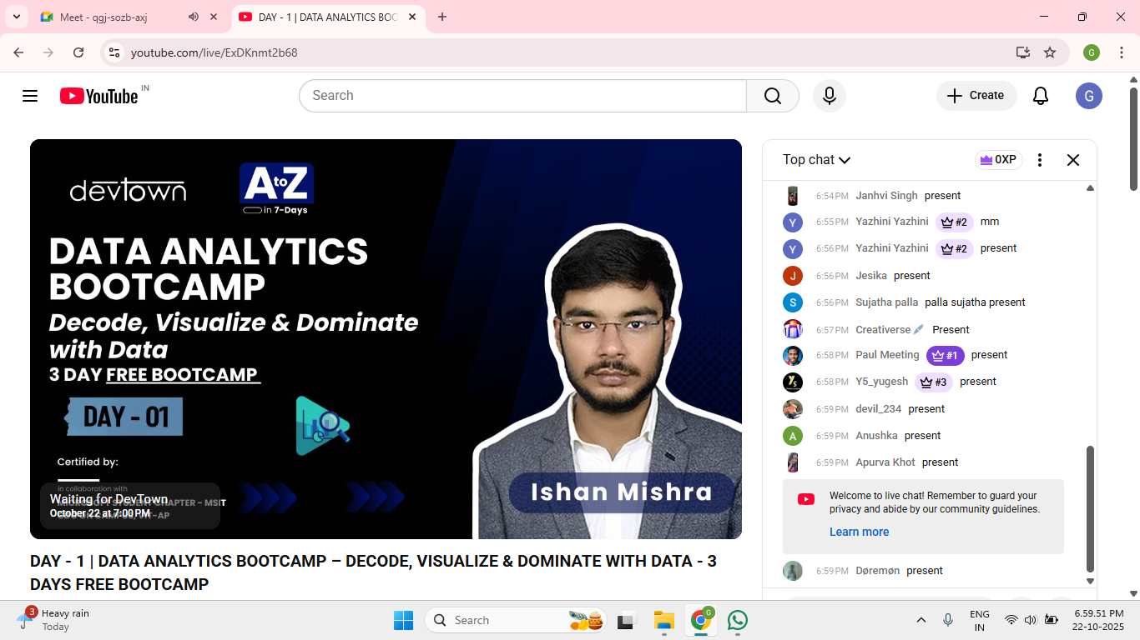

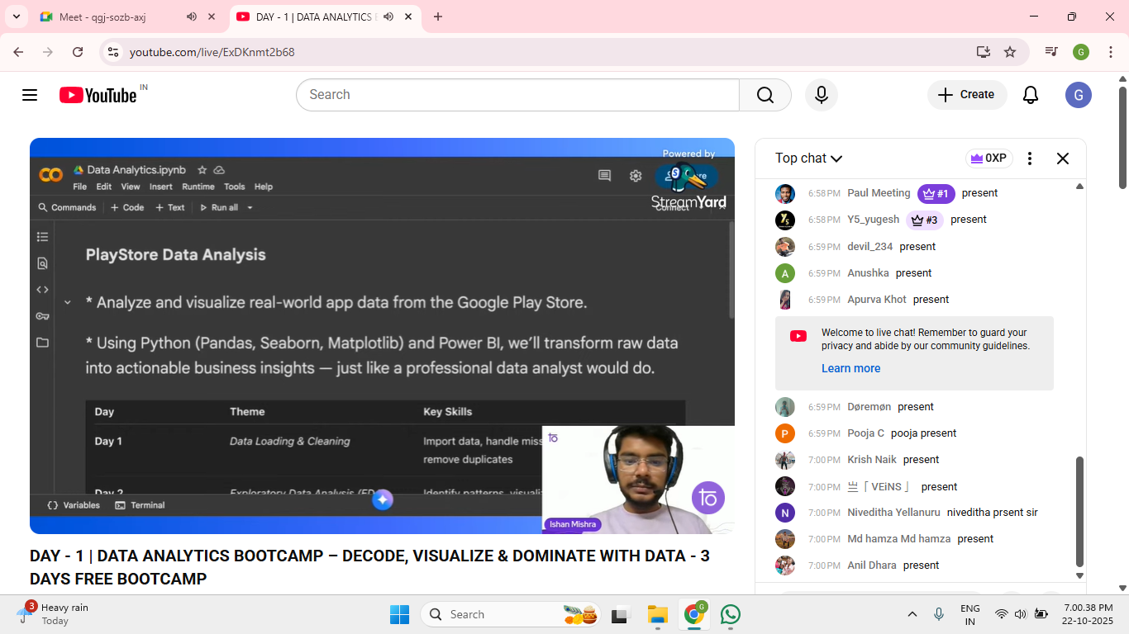

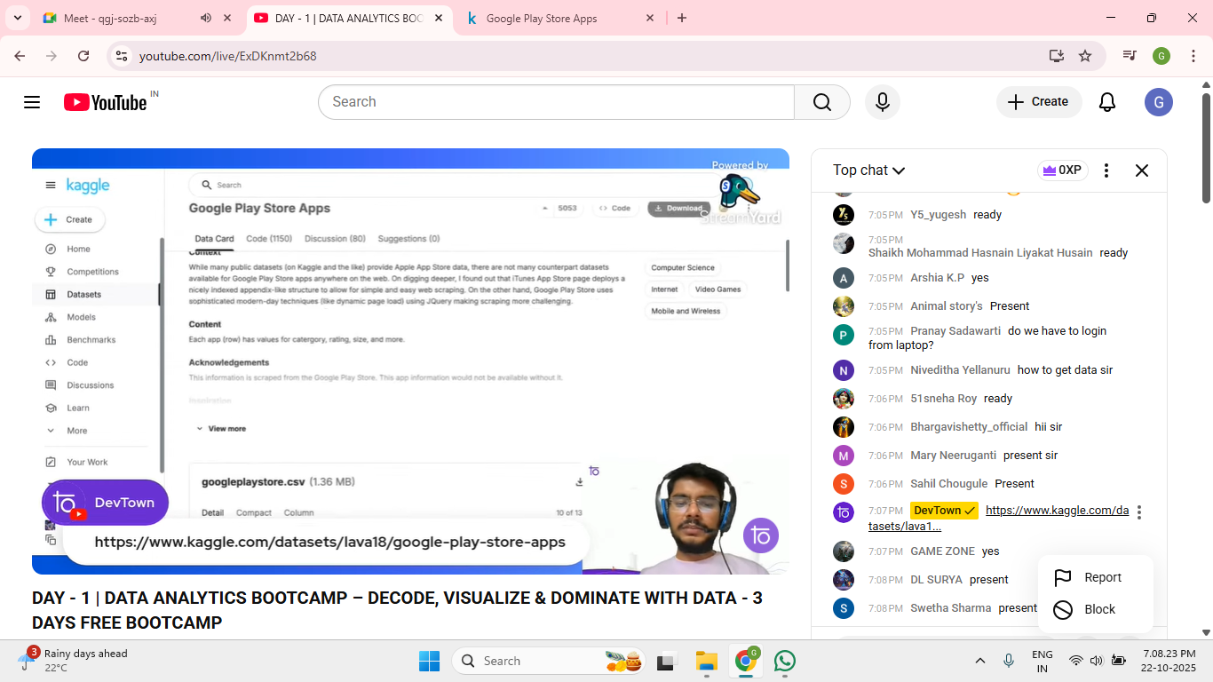

**DAY 2 SCREENSHOTS:**

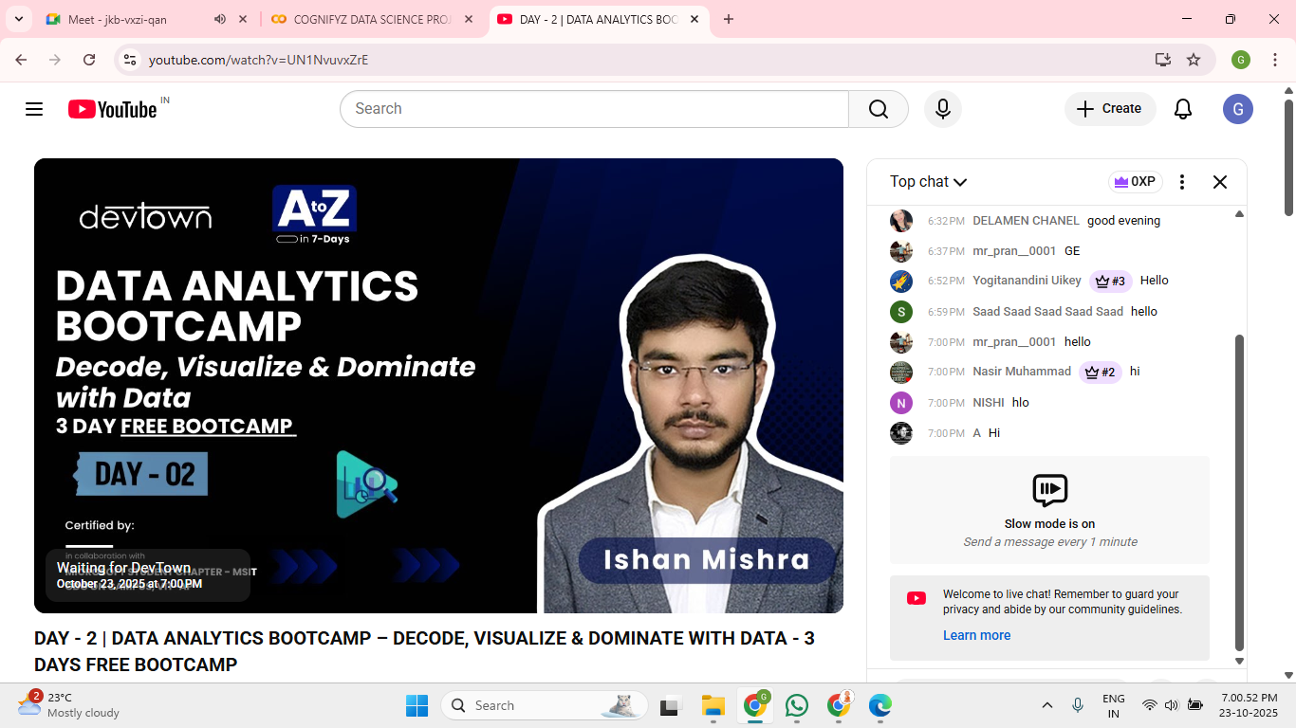

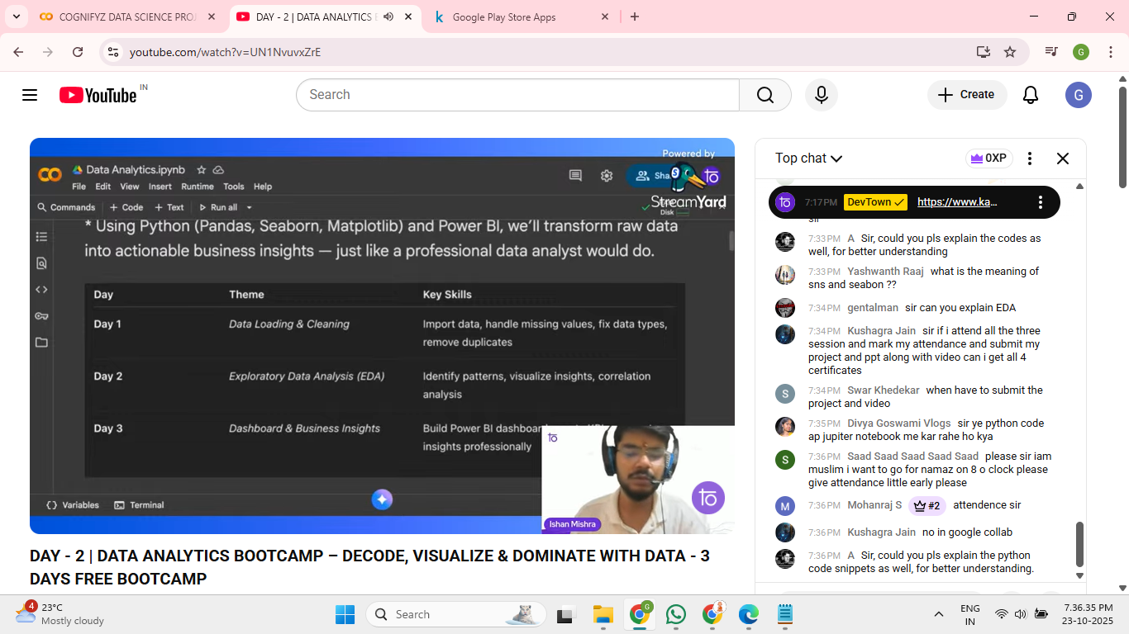

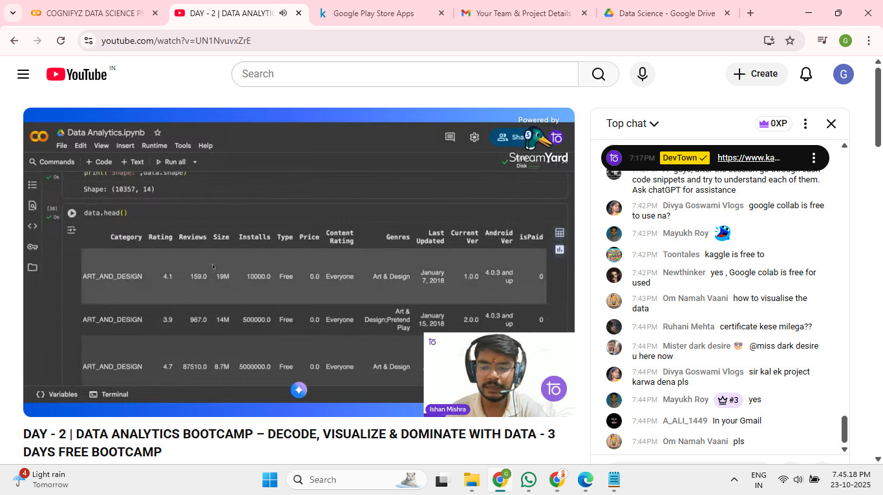

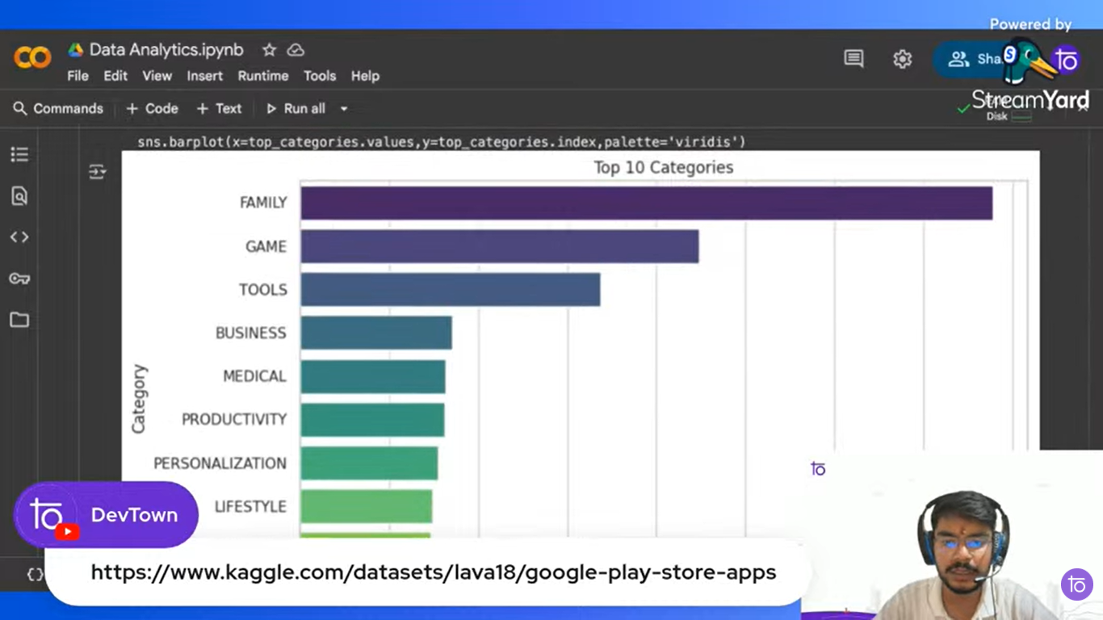

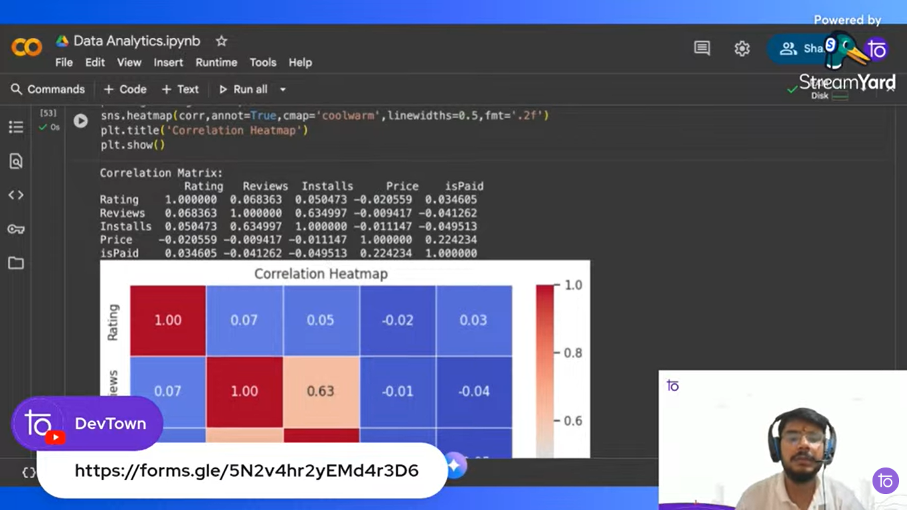

**DAY 3 SCREENSHOTS:**

